**KWAME NKRUMAH UNIVERSITY OF SCIENCE AND TECHNOLOGY**

**COLLEGE OF SCIENCE**

**DEPARTMENT OF COMPUTER SCIENCE**



TITLE:

**DESIGN AND IMPLEMENTATION OF A MULTI-LANGUAGE E-COMMERCE SITE**

A Project Work Submitted in Partial Fulfilment of the Requirements For

BACHELOR OF SCIENCE IN COMPUTER SCIENCE

**BY:**

WILLIAM KPABITEY KWABLA (2565814)

**SUPERVISOR:**

MR. KWAKU AGYAPONG PABBI

April, 2018

©

# DECLARATION

I hereby declare that this project work is the result of my original research and that no part of it has been presented to the university or elsewhere. As such, all use of previously published work (from magazines, internet and journals) has been acknowledged within the main report to an entry in the references list.

**AUTHOR**: William Kpabitey Kwabla **SIGNATURE**: ……………………….

**STUDENT ID**: 2565814 **DATE**: ……………………………….

**SUPERVISOR**: Mr. K.A Paabi **SIGNATURE**: ………………………

**HOD**: Dr. Asante **SIGNATURE**: ……………………….

**DATE**: ……………………………….

# ACKNOWLEDGEMENT

I have learned a lot and really enjoyed working on this project. I thank God Almighty who by His Grace and Mercy I have been able to complete this project.

My appreciation to my parents and guardians who have motivated me in diverse ways to come this far in my educational journey.

I am deeply indebted to my supervisor, Mr. KWAKU AGYAPONG PABBI, for his valuable guidance, stimulating suggestions, patience and for encouraging me to go ahead with my project. I am grateful.

I would like to sincerely thank all those who helped me with their valuable support during the entire process of this dissertation.

# ABSTRACT

The objective of this project is to develop a general-purpose e-commerce store where any product (such as books, CDs, computers, mobile phones, electronic items, and home appliances) can be bought from the comfort of home through the Internet.

However, for implementation purposes, this project will deal with an Information Technology (IT) online book store. It provides the user with different catalog of IT books available for purchase in the store.

In order to facilitate online purchase a shopping cart is provided to the user. The system is implemented using a three-tier approach, with a backend PostgreSQL database, a middle tier of Django, and a web browser as the front-end client.

This document will discuss each of the underlying technologies to create and implement an e-commerce website and outlines all the process followed to come up with the application that is from analysis to testing.

**TABLE OF CONTENTS**

DECLARATION i

ACKNOWLEDGEMENT ii

ABSTRACT iii

LIST OF ABBREVIATIONS viii

LIST OF TABLES ix

LIST OF FIGURES ix

CHAPTER ONE 1

INTRODUCTION 1

1.0 Introduction 1

1.1 Background to the Study 1

1.2 Overview of E-Commerce 3

1.3 Problem Statement 4

1.4 Motivation for the Project 5

1.5 General Objectives of the Study 5

1.6 Specific Objectives of the Study 5

1.7 Scope of Project 6

1.7.1 Visitor Features 6

1.7.2 Registered Member Panel 6

1.7.3 Online Shop Owners 7

1.7.4 Exclusions from scope 7

1.8 Definition and explanation of terms. 7

1.9 Project Activity Planning 10

1.10 Project beneficiaries 12

1.11 Limitations of the proposed system 13

1.12 Structure of Report (Content of Various Chapters) 14

1.13 Conclusion 16

CHAPTER TWO 17

LITERATURE REVIEW 17

2.0 Introduction 17

2.1 Overview of E-Commerce and Online Shopping 17

2.2 Current Research Issues in E-commerce Business 18

2.3 Past technologies that were employed in Ecommerce 19

2.4 Present Technologies Available in Food Ordering and Table Reservations 22

2.4.1 Disintermediation 22

2.4.2 Predictive analysis 23

2.4.3 Real-time customization 23

2.4.4 One-click checkouts 23

2.4.5 E-wallets 23

2.5 Highlights of Similar Implementations from Vendors 24

2.5.1 Amazon 24

2.5.2 Walmart 26

2.5.3 Jumia Ghana 27

2.5.4 Ahonya 28

2.5.5 Azaliabooks 29

2.5.6 eShopAfrica 30

2.5.7 Zoobashop 31

2.5.8 Telefonika 32

2.5.9 Cheki 33

2.5.10 Baahe 34

2.6 Review of Existing Implementations (Designs and Features) 35

2.7 Benefits and Challenges of Implementations 46

2.7.1 Benefits 46

2.7.2 Challenges 47

2.8 Trends in the Industry / Future Direction 47

2.8.1 Data-as-a-service and ecommerce 47

2.8.2 Chatbots 48

2.8.3 Drone Delivery 49

2.8.4 Droid Delivery 49

2.8.5 Augmented Reality Technology 50

2.8.6 Blockchain 51

2.8.7 Bitcoin 51

2.9 Summary 53

## LIST OF ABBREVIATIONS

## LIST OF TABLES

Table 1.0: The time interval for the development of the system. 11

## LIST OF FIGURES

Figure 1.0: Gantt Chart Representation of the Project Activity Planning 12

# CHAPTER ONE

## INTRODUCTION

## 1.0 Introduction

This chapter will introduce the project concept, outline the general objectives as well as the specific objectives that will eventually lead to the development of the project and the scope of the project. The chapter will also outline the timeline for the development of the project; specifying when each developmental phase will start and end, the limitations of the project and finally describe briefly what the subsequent chapters will entail.

## 1.1 Background to the Study

Technology has not only affected our mode of communication, transportation and education. It has also given businesses (buying and selling) a touch of the magic wand. Technology has made it easy for people to conduct businesses from the comfort of their mobile devices. Some buy whiles others also sell online to a vast number of customers worldwide.

E-commerce (electronic commerce or EC) is the buying and selling of goods and services, or the transmitting of funds or data, over an electronic network, primarily the internet. E-commerce covers a wide range of businesses ranging from retail sites, music sites, auction sites or the exchange of goods and services between corporations.

The beginnings of e-commerce can be traced to the 1960s, when businesses started using Electronic Data Interchange (EDI) to share business documents with other companies. In 1979, the American National Standards Institute developed ASC X12 as a universal standard for businesses to share documents through electronic networks. After the number of individual users sharing electronic documents with each other grew in the 1980s, in the 1990s the rise of eBay and Amazon revolutionized the e-commerce industry. Consumers can now purchase endless amounts of items online, both from typical brick and mortar stores with e-commerce capabilities and one another.

There are four types of E-Commerce business models. The four types of E-Commerce business models are B2C which stands for Business-to-Consumer, B2B which stands for Business-to-Business model, C2C which stands for Consumer-to-Consumer, and B2G which stands for Business-to-Government. When working, selling, or buying with any of these models, it is important to be familiar with what each model contains. B2C represents most of E-Commerce websites. Businesses that sell to consumers are considered B2C. Online stores and shopping are all examples of B2C. B2B are businesses selling products to other businesses. B2B are usually larger companies that are supplying a service to other businesses. For example, office max is a business that sells office supplies to other businesses. Also, they are almost always doing business over the web. C2C is a website that consumers sell to other consumers. People are brought together to sell and buy products for this model. For example, EBay is a common place for consumers to sell and buy items. B2G consists of businesses working with the government. For example, the IRS is a way for businesses to pay their taxes through the web. These four E-Commerce business models are very common in this day-in-age.

The benefits of e-commerce include its around-the-clock availability, the speed of access, the wide availability of goods and services for the consumer, easy accessibility, and international reach. Its perceived downsides include sometimes-limited customer service, consumers not being able to see or touch a product prior to purchase, and the necessitated wait time for product shipping.

The e-commerce market continues to grow: Online sales accounted for more than a third of total U.S. retail sales growth in 2015, according to data from the U.S. Commerce Department. Web sales totaled $341.7 billion in 2015, a 14.6% increase over 2014. E-commerce conducted using mobile devices and social media is on the rise as well: Internet Retailer reported that mobile accounted for 30% of all U.S. e-commerce activities in 2015. And according to Invesp, 5% of all online spending was via social commerce in 2015, with Facebook, Pinterest and Twitter providing the most referrals.

## 1.2 Overview of E-Commerce

Ecommerce began to gain traction in the early nineties and has grown rapidly ever since. Ecommerce offers many advantages over traditional brick and mortar stores. Consumers can easily search for the products and services they are looking for. Online retailers, or e-tailers, are incredibly convenient, in that they are available twenty-four hours a day. Today, most brick and mortar retailers such as Walmart also have an ecommerce option. While an ecommerce consumer does not get the immediate gratification of having their purchase immediately in hand, they can place orders from the comfort of their own home without having to deal with the hustle and bustle of a shopping mall. Some stores offer a combination, allowing a customer to order their merchandise online, and pick it up almost immediately at their local store. E-tailer sites like Amazon paved the way for many others. Amazon is arguably one of the most successful e-tailer sites around. It began as an online bookstore with a primary focus on the customer experience. It was so successful that it did not take long before it expanded beyond the sale of books. Today, you can order almost anything from Amazon. They have also crossed over from strictly being an e-tailer to an e-tailer and subscription site with its Amazon Prime offering.

Online shopping remains the most popular type of e-commerce. Sellers create online or mobile stores which are similar to face-to-face retail shops. Buyers visit these stores, browse through items available, and if they like the items’ quality and price, they will select it, make payments online and the goods or services will be delivered to them. Currently, the global leader in this space is www.amazon.com, which does not only serve as a seller but also creates opportunity for others to use its platform to sell their goods and services.

## 1.3 Problem Statement

A key role of e-commerce over brick-and-mortar retail is the ability to easily expand your business's geographical borders. But according to a PayPal report, U.S.-based small businesses could be doing a lot more to reach global online shoppers. Modern e-commerce websites are restricted to more often than not; to the language of the country the developers are from. In particular, American e-commerce merchants aren't tailoring the shopping experience to local customers outside their home country: Only 19 percent translate their website copy from English, and less than half list foreign currency options on their sites. Global customers are much more likely to make purchases when product descriptions and prices are available in their native language/currency, PayPal found.

The E-commerce business in Ghana is growing at a fast pace and most of these Ghanaian online retailers face the same language barrier problem because they develop their online shops only in English. This limits the market share and customer base because Ghana is a diverse country with different people from different countries who speak different languages.

Moreover, most of the current e-commerce business do not create an interface for other services to interact with their Online shops. This makes it difficult for developers to inculcate a feature of these e-commerce websites in their projects.

These problems are faced by Online Shoppers and Developers today and it is my hope that by the end of this project, all these issues would be addressed and resolved.

## 1.4 Motivation for the Project

The main aim of the project is to develop a simple and easy-to-use online shopping system with the functionality of making the shop available in different language for the different people across the globe, provide shop management with an effective and efficient system to handle client’s data, request, maximize income through online payment using PayPal, create an interface for other services to interact with my web application. By building an API, I can allow third parties to consume information and operate with your application programmatically.

## 1.5 General Objectives of the Study

The main aim of the project is to develop a simple and easy-to-use online shopping system with the functionality of making the shop available in different language for the different people across the globe and also create an interface (API) for other services to interact with my web application.

## 1.6 Specific Objectives of the Study

In order to attain the general objective, the following list of specific objectives is set:

* To enable shopping online.
* To make buying and selling easier.
* To enable customers from different countries, shop with ease from their country or when in Ghana.
* To provide shop management with an effective and efficient system to handle client’s data and request.
* To help expand the market of shops and make it available to a worldwide audience.
* To enable other developer’s applications, communicate with the online shop using APIs.
* To provide customers access to discounts and special pricing.

## 1.7 Scope of Project

This project is developed for three types of users and they are Visitors, Customers (Registered Member) and Online shop owners. The application consists of following main sections (inclusions):

## 1.7.1 Visitor Features

* Multi Lingual (English, Spanish, French, Chinese, Dutch, German, Portuguese)
* View Home Banners or Slide Show Gallery
* Browse Products
* View Product Details
* View FAQs
* Become a Member through Registration process
* View Static Pages (Contact Us, About Us, Privacy Policy, Disclaimer, Terms & Conditions)
* Debit and Credit Card Payments with PayPal
* Product Recommendations

## 1.7.2 Registered Member Panel

* Login to site
* Manage Account

My Profile

My Orders

* Buy Product (Checkout)
* Logout

## 1.7.3 Online Shop Owners

* Login
* Dashboard
* Administrator User Management
* Site Member (Customer) Management
* Product Management
* Banner Manager
* Order Manager
* Shipping Management
* FAQ Management
* Email Templates
* Static Page Content Management
* Location Management (Country/State/City)
* System Settings
* Logout

## 1.7.4 Exclusions from scope

The following is a list of activities that are clearly excluded scope of development for this project:

* Mobile Money Payments.

## 1.8 Definition and explanation of terms.

**E-commerce:** The act of doing business transactions over the Internet or similar technology.

**Brick-and-mortar store:** A conventional store with a physical presence.

**Brokerage site:** A type of Web site that brings buyers and sellers together to facilitate transactions between them; the site earns revenue in the form of commissions on sales made via the site.

**Digital wallet:** A program or online service that holds a buyer’s information (such as electronic payment, billing, and shipping information) that can be used to speed up online purchase transactions.

**Dot-com:** An Internet-only store with no physical presence.

**Meta tag:** A special HTML or XHTML tag containing information about a Web page that is added by the person creating the Web page and is used primarily by search sites.

**Online auction site:** A Web site where potential buyers bid on an item and, at the end of a set time period, the highest bidder buys the item as long as all bidding criteria (such as minimum selling price) have been met.

**Online payment service:** A type of payment service accessed via the Internet and used to make electronic payments to others, such as via deposited funds, a bank account, or a credit card.

**Search engine optimization (SEO):** The process of evaluating a Web site and making changes to improve search site results. Search engine optimization is one way that a website can make themselves more easily found online when being searched for through search engine websites like Google.

**Shopping cart software:** E-commerce software designed to add ordering capabilities to an existing Web site.

**Storefront software:** E-commerce software that facilitates the creation of an online store.

**Subscription site:** A site that sells access to its online content.

**Order:** This is a request to supply or deliver food booked by diners far in advance before due date and time.

**Back-end:** This is a specialized subordinate process or a module that is not directly accessible by the user. This part of the application allows the administrator to interact with the software. This part of the software is where menu details that would be available to the user to place order is entered. Reports generation and basic managerial operations occur at the back-end. We usually refer to this part of the system as the server side of the software application.

**Front-end:** In software development, front-end is that part of the software that the user interacts with in performing his or her functions. It usually consists of Graphical User Interface which makes it easy for users to either login, place food order, reserve a table etc. It is sometimes referred to as the client side of the application

**Responsive display:** Is an approach to web design and development whereby websites and web applications respond to a screen size of the device on which they are being accessed. The response includes layout changes, rearrangement of content, and in some cases selective display or hiding of content elements. Using a responsive web design approach, you can optimize web pages to achieve great user experience on a range of devices from smartphones to desktop.

## 1.9 Project Activity Planning

Planning is an essential part of any successful web design project. By outlining the scope of your project at its onset, you will be better equipped to identify and avoid roadblocks that would otherwise steer your progress off track. One of the most effective tools for planning your project is the schedule. A project schedule allows you to outline, assess, and communicate the essentials of a job, and includes its deliverables, timeframe, and the resources allotted to individual tasks.

The Gantt chart is one of the most popular scheduling documents for managing projects in the creative industry. A Gantt chart is a simple two-dimensional schedule that outlines the anticipated timeline of your client’s project. They are most suitable for jobs spanning a few months.

This project is expected to span a period of six months starting from the 20th October, 2017 to 20th March, 2018 by which I hope to have finished the project and its associated documentation.

This project is expected to go through these development phases before its completion:

* **Analysis Phase**

This phase involves studying the existing systems which will help in getting clearly the requirements for the proposed system. This phase is where the team will define the problem it intends to solve. I will use the various techniques in information gathering to obtain user and system requirements.

* **Design Phase**

After the necessary requirements for the proposed system are gathered from the analysis phase, the design phase then sets in. This phase basically involves detailed specification of the proposed system. This phase is where most of the work will be done and it will include such things as coding and database design of the proposed system.

* **Implementation and Testing Phase**

During this phase, the newly developed system is tested and implemented. In implementing this system, the actual system is installed on a selected vender where the various configuration will be set by the administrator. During the system testing, I shall talk about unit testing, Incremental integration testing, integration testing, functional testing and the whole system testing. This phase also includes associated documentation of the new system that would be delivered to our supervisor.

### **Table 1.0: The time interval for the development of the system.**

|  |  |
| --- | --- |
| **PHASE** | **TIME INTERVAL** |
|  |  |
| Analysis | 20th October, 2017 – 14th November, 2017 |
|  |  |
| Design | 23rd November, 2017 – 23rd December, |
|  | 2017 |
|  |  |
| Coding | 1st January, 2018 – 15th April, 2018 |
|  |  |
| Implementation | 16th April, 2018 – 30th April, 2018 |
|  |  |
| Documentation | 14h October, 2017 – 20th April, 2018 |
|  |  |

|  |  |  |  |  |  |  |
| --- | --- | --- | --- | --- | --- | --- |
| Activities |  |  |  |  |  |  |
| Analysis Phase |  |  |  |  |  |  |
|  |  |  |  |  |  |
| Design Phase |  |  |  |  |  |  |
|  |  |  |  |  |
| Coding |  |  |  |  |  |  |
|  |  |  |  |  |  |
| Implementation /Testing |  |  |  |  |  |  |
|  |  |  |  |  |  |  |
|  |  |  |  |  |  |  |

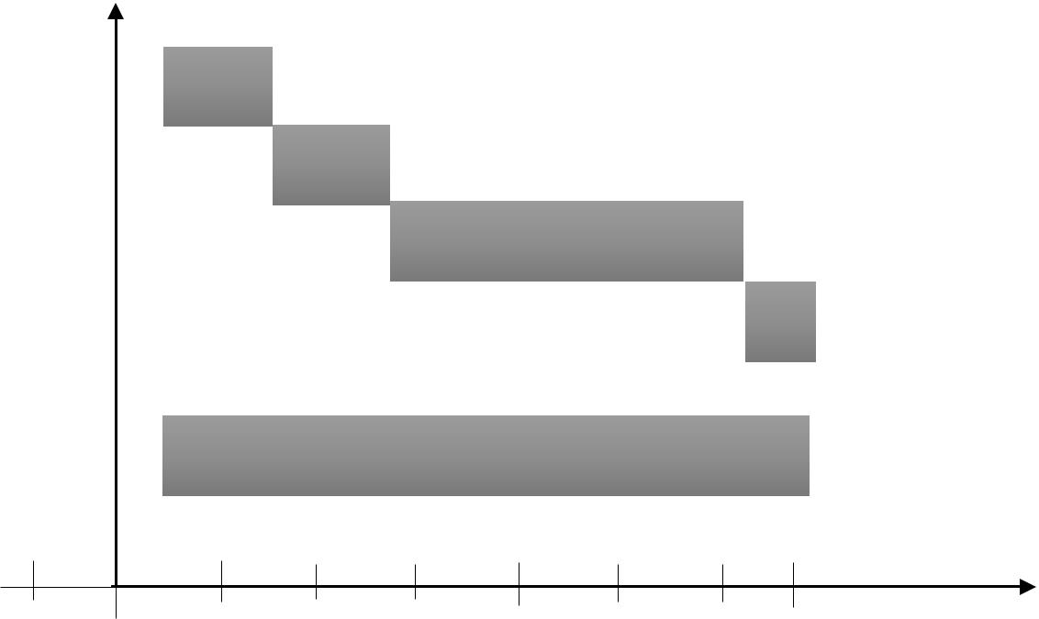

Documentation

Sept Oct Nov Dec Jan Feb Mar Apr *Months*

**

**2017 2018**

### **Figure 1.0: Gantt Chart Representation of the Project Activity Planning**

## 1.10 Project beneficiaries

At the end of this project, I hope to have acquired some benefits for:

* Customers who do not understand the English language since the project has a feature that converts the content of the entire website to his/her desired language. It also offers them convenience to shop 24 hours a day and seven days a week without having to leave their homes or offices.
* Shop Owners are also huge beneficiaries of the system. Since they are able to explore other markets and countries by putting their shops on the electronic highway making people from different countries access the website and patronize their products or services without limiting them to only a physical location of their store. This also helps owners cut down cost because they don’t need to build, staff or maintain a store or print and distribute mail order catalogues. Automated order tracking and billing systems cut additional labour costs.
* This project will also help other developers to have an easy way around integrating features of this project into their own websites.

I also perceive the following benefits after successful completion of the project:

* To have enhanced my programming skills since this project will expose me to the use of some new programming techniques.
* To have better insight as to what a software system documentation really entails and how to document properly.
* To have developed better working ethics including being time conscious as well as developing the right attitude towards team work.

## 1.11 Limitations of the proposed system

Every research has challenges and this project is no exception and some of the limitations of this project are:

* The application will require internet connection and also the user must be a computer literate. The Owners has to incur debt in hosting their site online shop so that people can browse the site and place orders.
* The set back of the system is that the customers targeted are adults with access to computer systems and mobile phones with internet capabilities. People who cannot afford these resources cannot engage in shopping online.
* Time Constraint is also going to be a major challenge in developing this system. I will be doing everything possible to finish the project on time so as to submit the final work and documentation to my supervisor. Within this six (6) month of developing the system, there will be things that will happen along the way which will be inevitable. Going for lectures, writing mid-semester examinations, assignments and writing of examination will all interfere with the smooth development of this system and might cause delay in delivery of the final output.
* Because the system will be responsive, I need to acquire some tablets, android phones, laptops etc. during the system development in order to do the testing to see that it is actually working. All these hardware parts have to be either bought or borrowed from friends because I as the developer does not have most of the equipments.

## 1.12 Structure of Report (Content of Various Chapters)

This document contains six chapters including this chapter. The following describes the structure of the report which will comprise of the contents of the various chapters in the system development.

Chapter one entails introduction to the proposed system, motivation for the proposed system, the general objectives as well as specific objectives to be achieved at the end of the project. It also consists of the project scope as to who the proposed system applies to as well as what the system can do and what it cannot do. This chapter consist of the project activity planning which details out the allocated time scheduled for each development stage. This include a Gantt chart giving a pictorial view of the project activities.

Chapter two introduces literature review where an overview of the subject area will be discussed. Past and present technologies that applies to the proposed system will also be discussed. This chapter will also include the review of existing implementations including highlights from similar vendors. The benefits and challenges of implementing the system will also be discussed. This chapter concludes with a summary of the chapter content.

In chapter three, the development methodologies and development tools that will be used in the design and implementation of the system will be looked at. A brief description of the various methodologies including the advantages, limitations and also the general system architecture of the proposed system. I will also introduce the programming language we shall use in developing the backend as well as the frontend of the system.

Chapter four will explain the system’s analysis and its design. This chapter will contain details of the various methods used in requirements capture and specification such as interviews, observations, questionnaires, etc. It will also include details on data driven applications. The proposed system’s requirements specification that is, the event driven applications will be looked at in this chapter. This will take a critical look at the functional and non-functional requirements of the proposed system. Use Case modelling including the various diagrams which will be used where appropriate will be explained. The proposed system’s database design and its associated details together with the user interface will be looked at as well.

Chapter five will introduce the implementation of the system. It will talk about mapping logical design onto physical form as well the various construction involved. The results of testing the system will be explained in this chapter. Evaluation of the project will also be detailed out in this chapter.

Chapter six which happens to be the final chapter will consist of findings and conclusion. This will include summary of various problems faced in the development of the system, achievements and challenges, recommendations as well as enhancements that can be made to the system in future.

## 1.13 Conclusion

In conclusion, this chapter basically introduced us to the proposed system I wish to develop for the E-commerce Businesses in Ghana. I have looked at the general objective as well as the specific objectives expected to be accomplished at the end of the project. I have also looked at the scope which basically talked about the inclusions and exclusions of the proposed system as well as who the system applies to. I also looked at the project activity planning where I introduced the various phases in my development. The limitations of the proposed system were also looked at in this chapter as well as using Gantt chart to represent the project activity and the time interval for the completion of the project. The chapter also talked about the structure of this report which details the content of the various chapters.

# CHAPTER TWO

## LITERATURE REVIEW

## 2.0 Introduction

Literature Review is a summary of previous research on a topic and can also be a part of a larger report of a research project. This chapter explains facts or statements which will be used as guidance in developing the system. It will include reviewing the subject area, past and present technologies, research issues that are currently available, highlights of similar implementation from vendors, review of existing implementations, benefits and challenges of implementations and the trends in the industry or future directions for E-Commerce.

## 2.1 Overview of E-Commerce and Online Shopping

Before setting out a business, one needs to know his target audience or market. These business transactions occur either as business-to-business, business-to-consumer, consumer-to-consumer or consumer-to-business.

Business to consumer (B2C) is business or transactions conducted directly between a company and consumers who are the end-users of its products or services. The business-to-consumer as a business model differs significantly from the business-to-business model, which refers to commerce between two or more businesses. While most companies that sell directly to consumers can be referred to as B2C companies, the term became immensely popular during the dotcom boom of the late 1990s, when it was used mainly to refer to online retailers, as well as other companies that sold products and services to consumers through the internet.

Business to consumer (B2C) is among the most popular and widely known of sales models. The business-to-consumer aspect of electronic commerce (e-commerce) is the most visible business use of the World Wide Web. The idea of B2C was first utilized by Michael Adrich in 1979, who used television as the primary medium to reach out to consumers. Traditionally, B2C referred to mall shopping, eating out at restaurants, pay-per-view and infomercials. However, the rise of the internet created a whole new B2C business channel in the form of e-commerce or selling goods and services over the internet. Online stores and shopping are all examples of B2C.

An online store is a virtual store on the Internet where customers can browse the catalogue and select products of interest. The selected items may be collected in a shopping cart. At checkout time, the items in the shopping cart will be presented as an order. At that time, more information will be needed to complete the transaction. Usually, the customer will be asked to fill or select a billing address, a shipping address, a shipping option, and payment information such as credit card number. An e-mail notification is sent to the customer as soon as the order is placed.

## 2.2 Current Research Issues in E-commerce Business

E-commerce has eliminated a lot of barriers for aspiring business owners. It is easier than ever to set up an online shop and market your goods to shoppers across the globe. But just because it's easy to get into the e-commerce game, doesn't mean it's easy to stay on top. Here are a few common research issues online retailers are facing right now:

* **International sales**

Once an e-commerce merchant has established itself as a national retailer, the next frontier is to expand overseas. However, the number of legal and shipping hurdles required to sell internationally can make some smaller businesses hesitant to jump into the global market because other countries have different commerce regulations.

#### **Payment fraud**

One of the biggest concerns today's consumers have is the risk of fraud when they're shopping online. With highly sophisticated malware and savvy cybercriminals, customers' card and bank information can easily be stolen if a merchant doesn't take the proper security measures.

* **Shipping and tracking**

Same and next day delivery, easy tracking options, and hassle-free return policies are just a few of the standards that e-commerce giants have set in place for the industry. Customers have come to expect this level of service, no matter what site they're purchasing from, which places a lot of pressure on small retailers

## 2.3 Past technologies that were employed in Ecommerce

Ecommerce was introduced 40 years ago and, to this day, continues to grow with new technologies, [innovations](https://www.miva.com/ecommerce-software-features?utm_source=organic&utm_medium=blog&utm_content=%E2%80%9Cthe-history-of-ecommerce-how-did-it-all-begin%E2%80%9D), and thousands of businesses entering the online market each year. The convenience, safety, and user experience of ecommerce has improved exponentially since its inception in the 1960’s.

* **1960 – 1982**

Paving the way for electric commerce was the development of the [Electronic Data Interchange](https://www.covalentworks.com/what-is-edi.asp)(EDI). EDI replaced traditional mailing and faxing of documents with a digital transfer of data from one computer to another.  
Trading partners could transfer orders, invoices and other business transactions using a data format that met the ANSI ASC X12, the predominant set of standards in North America.

Once an order is sent, it is then examined by a VAN (Value-Added Network) and finally directed to the recipient’s order processing system. EDI allowed the transfer of data seamlessly without any human intervention.

[Michael Aldrich](https://www.aldricharchive.com/inventors_story.html), an English inventor, innovator and entrepreneur is credited with developing the predecessor to online shopping. The idea came about during a stroll with his wife and Labrador when Aldrich lamented about their weekly supermarket shopping expedition. This conversation sparked an idea to hook a television to their supermarket to deliver the groceries. Immediately after the discussion Aldrich quickly planned and implemented his idea.

In 1979 Aldrich connected a television set to a transaction processing computer with a telephone line and created what he coined, “teleshopping,” meaning shopping at a distance.

* **1982 – 1990**

It was apparent from the beginning that B2B online shopping would be commercially lucrative but B2C would not be successful until the later widespread use of PC’s and the World Wide Web, also known as, the Internet. In 1982, France launched the precursor to the Internet called, [Minitel.](https://www.teleread.com/net-related-tooks-from-search-engines-to-blogware/olpc-lessons-from-minitel/)

The online service used a Videotex terminal machine that was accessed through telephone lines. The Minitel was free to telephone subscribers and connected millions of users to a computing network.

By 1999, over 9 million Minitel terminals had been distributed and were connecting approximately 25 million users in this interconnected network of machines. The Minitel system peaked in 1991 and slowly met its demise after the success of the Internet 3 years later. Eventually, in 2011, France Telecom announced its [shutdown of the Minitel service system](https://www.pcmag.com/article2/0,2817,2389164,00.asp#fbid=-1XmaaLOFxc). Sadly, it had not become what it had hoped to be, the Internet.

* **1990 - 2000**

In 1990 Tim Berners Lee, along with his friend Robert Cailliau, published a proposal to build a “Hypertext project” called, “Worldwide Web.” The inspiration for this project was modeled after the Dynatex SGML reader licensed by CERN.

That same year, Lee, using a NeXTcomputer created the first web server and wrote the first web browser. Shortly thereafter, he went on to debut the web on Aug. 6, 1991 as a publicly available service on the Internet. When Berner’s Lee decided he would take on the task of marrying hypertext to the Internet, in doing that, the process led to him developing URL, HTML and HTTP.

When the National Science Foundation lifted its restrictions on commercial use of the NET in 1991, the Internet and online shopping saw remarkable growth. In September 1995, the NSF began charging a fee for registering domain names.  120,000 registered domain names were present at that time and within 3 years that number grew to beyond 2 million.  By this time, NSF’s role in the Internet came to an end and a lot of the oversight shifted to the commercial sector.

From the beginning, there were many hesitations and concerns with online shopping but the development of a security protocol – the [Secure Socket Layers](https://www.evsslcertificate.com/ssl/ssl-history.html) (SSL) – encryption certificate by Netscape in 1994 provided a safe means to transmit data over the Internet. Web browsers were able to check and identify whether a site had an authenticated SSL certificate and based on that, could determine whether or not a site could be trusted.

Now, SSL encryption protocol is a vital part of web security and version 3.0 has become the standard for most web servers today.

## 2.4 Present Technologies Available in Food Ordering and Table Reservations

Beginning in 2007 with the introduction of the iPhone, to the present day, e-commerce has been transformed yet again by the rapid growth of online social networks, widespread adoption of consumer mobile devices such as smartphones and tablet computers, and the expansion of e-commerce to include local goods and services. The defining characteristics of this period are often characterized as the “social, mobile, local” online world.

E-Commerce business have evolved over the past years with new technologies making online shopping easier for customers.

Disintermediation, Predictive analysis, Real-time customization, one-click checkouts, E-wallets are some of the more prominent innovations that have transformed the e-commerce industry.

## 2.4.1 Disintermediation

Millennials now deal directly with the brands, so it’s only natural that the relationship between end users and brands have becoming less circuitous. These same brands and manufacturers have pull out all the stops to make the sale with the end user (Direct-to-consumer or D2C), to the detriment of their traditional distribution channels, the distributors and merchants.

Conversely, distributors and merchants now cement their relationship with the customer by becoming indispensable and by offering added value: warranties, complementary services and, of course, independence from the brands. This trend, called disintermediation, have taken hold in both B2C and B2B commerce, where automated processes and CRM systems are being used more than ever to maintain relationships and to simplify the ordering process.

## 2.4.2 Predictive analysis

Predictive analysis is a technology that has quickly gained popularity with merchants. By exploiting the massive amount of data (Big Data) collected through interactions and customer profiles or personas, merchants use predictive analysis to better understand consumers’ purchasing habits, preferences, and, yes, even their next purchases, based on the behavior of other customers with similar profiles.

## 2.4.3 Real-time customization

Each shopper now has access to unique content: product recommendations and add-ons chosen based on their preferences, geographic location, market trends, demographic group, past purchases, and brand interactions—all completely automatically. Even better, their next visit is entirely different because it will be based on the previous one and on the merchant’s current promotions.

## 2.4.4 One-click checkouts

Mobile shopping carts are the most popular of the bunch, and are responsible for completing almost half of all sales in ecommerce. The [popularity of mobile couponing](https://www.readycloud.com/info/one-click-savings-a-quick-look-at-2015-mobile-coupon-statistics) is feeding these conversions, but one-click checkouts have become a game-changer in ecommerce because they cater to a user’s behavior and past shopping experience to generate strong conversion thresholds.

## 2.4.5 E-wallets

The upgrades to consumers’ mobile devices and merchants’ point-of-sale systems have spell the end of the traditional wallet for many people now, especially since “mobile” payments are possible using more than just a smart phone—watches, rings, and other devices and “wearables” are now connected and capable of making payments. Merchants have set themselves up to accept these new payment methods.

Payment processors are hopping on the e-wallet bandwagon as quickly as they can. Apple Pay, Samsung Pay, PayPal, Stripe, Google, SlydePay Wallet have made checking out a simpler and more secure now. The biggest hang-up at the present is the lack of integration between retailers. Checkouts have got one-click easier during online shopping than at our favorite brick and mortar stores, restaurants and pharmacies.

## 2.5 Highlights of Similar Implementations from Vendors

There are several implementations of online shops and I would like to highlight ten of them from different vendors and they are:

## 2.5.1 Amazon

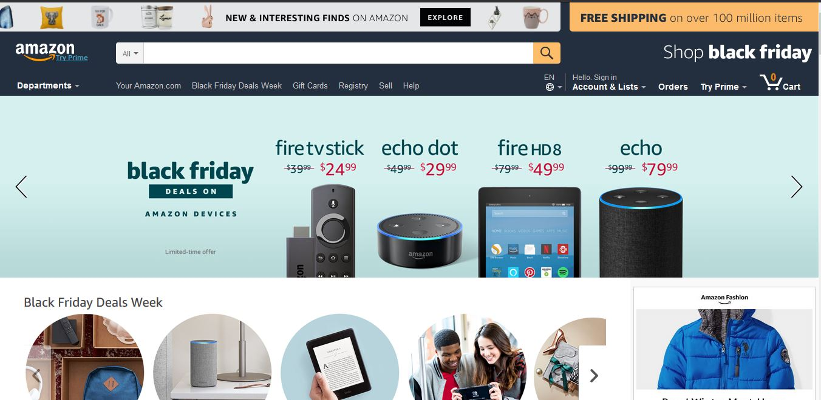

**Amazon.com, Inc.**, [doing business as](https://en.wikipedia.org/wiki/Doing_business_as) **Amazon** is an American [electronic commerce](https://en.wikipedia.org/wiki/E-commerce) and [cloud computing](https://en.wikipedia.org/wiki/Cloud_computing) company based in [Seattle, Washington](https://en.wikipedia.org/wiki/Seattle,_Washington) that was founded by [Jeff Bezos](https://en.wikipedia.org/wiki/Jeff_Bezos) on July 5, 1994. The tech giant is the largest [Internet retailer](https://en.wikipedia.org/wiki/Internet_retailer) in the world measured by [revenue](https://en.wikipedia.org/wiki/Revenue) and [market capitalization](https://en.wikipedia.org/wiki/Market_capitalization), and second largest after [Alibaba Group](https://en.wikipedia.org/wiki/Alibaba_Group) in terms of [total sales](https://en.wikipedia.org/wiki/Total_sales). The amazon.com website started as an online [bookstore](https://en.wikipedia.org/wiki/Bookstore) and later diversified to sell [DVDs](https://en.wikipedia.org/wiki/DVD), [Blu-rays](https://en.wikipedia.org/wiki/Blu-ray), [CDs](https://en.wikipedia.org/wiki/Compact_Disc), [video](https://en.wikipedia.org/wiki/Amazon_Video) downloads/streaming, [MP3](https://en.wikipedia.org/wiki/MP3) downloads/streaming, [audiobook](https://en.wikipedia.org/wiki/Audible.com) downloads/streaming, [software](https://en.wikipedia.org/wiki/Software), [video games](https://en.wikipedia.org/wiki/Video_game), [electronics](https://en.wikipedia.org/wiki/Consumer_electronics), apparel, furniture, food, toys, and jewelry. The company also produces [consumer electronics](https://en.wikipedia.org/wiki/Consumer_electronics)—[Kindle](https://en.wikipedia.org/wiki/Amazon_Kindle) [e-readers](https://en.wikipedia.org/wiki/E-reader), [Fire](https://en.wikipedia.org/wiki/Kindle_Fire) [tablets](https://en.wikipedia.org/wiki/Tablet_computer), [Fire TV](https://en.wikipedia.org/wiki/Fire_TV), and [Echo](https://en.wikipedia.org/wiki/Amazon_Echo)—and is the world's largest provider of [cloud infrastructure](https://en.wikipedia.org/wiki/Cloud_infrastructure) services ([IaaS](https://en.wikipedia.org/wiki/IaaS) and [PaaS](https://en.wikipedia.org/wiki/Platform_as_a_service)). Amazon also sells certain low-end products like USB cables under its in-house brand AmazonBasics.

Amazon has separate retail websites for the United States, the United Kingdom and Ireland, France, Canada, Germany, Italy, Spain, Netherlands, Australia, Brazil, Japan, China, India, and Mexico. In 2016, Dutch, Polish, and Turkish language versions of the German Amazon website were also launched. Amazon also offers international shipping to certain other countries for some of its products.

## 2.5.2 Walmart

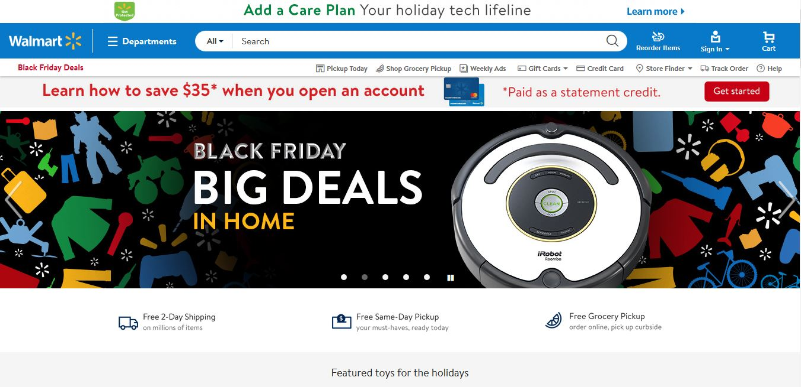

**Wal-Mart Stores, Inc.,** [doing business as](https://en.wikipedia.org/wiki/Doing_business_as) **Walmart**, is an American [multinational](https://en.wikipedia.org/wiki/Multinational_corporation) [retail](https://en.wikipedia.org/wiki/Retail) [corporation](https://en.wikipedia.org/wiki/Corporation) that operates as a [chain](https://en.wikipedia.org/wiki/Chain_store) of [hypermarkets](https://en.wikipedia.org/wiki/Hypermarket), [discount department stores](https://en.wikipedia.org/wiki/Discount_department_store), and [grocery stores](https://en.wikipedia.org/wiki/Grocery_store). Headquartered in [Bentonville, Arkansas](https://en.wikipedia.org/wiki/Bentonville,_Arkansas), the company was founded by [Sam Walton](https://en.wikipedia.org/wiki/Sam_Walton) in 1962 and [incorporated](https://en.wikipedia.org/wiki/Incorporation_(business)) on October 31, 1969. It also owns and operates [Sam's Club](https://en.wikipedia.org/wiki/Sam%27s_Club) [retail warehouses](https://en.wikipedia.org/wiki/Warehouse_club). As of January 31, 2017, Walmart has 11,695 stores and clubs in 28 countries, operating under 63 different names. The company operates under the name Walmart in the United States and Canada. It operates as [Walmart de México y Centro America](https://en.wikipedia.org/wiki/Walmart_de_M%C3%A9xico_y_Centroam%C3%A9rica) in Mexico and Central America, as [Asda](https://en.wikipedia.org/wiki/Asda) in the United Kingdom, as the [Seiyu Group](https://en.wikipedia.org/wiki/Seiyu_Group) in Japan, and as Best Price in India. It has [wholly-owned](https://en.wikipedia.org/wiki/Wholly-owned) operations in Argentina, Chile, Brazil, and Canada.

Walmart is the [world's largest company by revenue](https://en.wikipedia.org/wiki/List_of_companies_by_revenue) – approximately [US$](https://en.wikipedia.org/wiki/US$)480 billion according to the [Fortune Global 500](https://en.wikipedia.org/wiki/Fortune_Global_500) list in 2016 – as well as the [largest private employer](https://en.wikipedia.org/wiki/List_of_largest_employers) in the world with 2.3 million employees.

## 2.5.3 Jumia Ghana

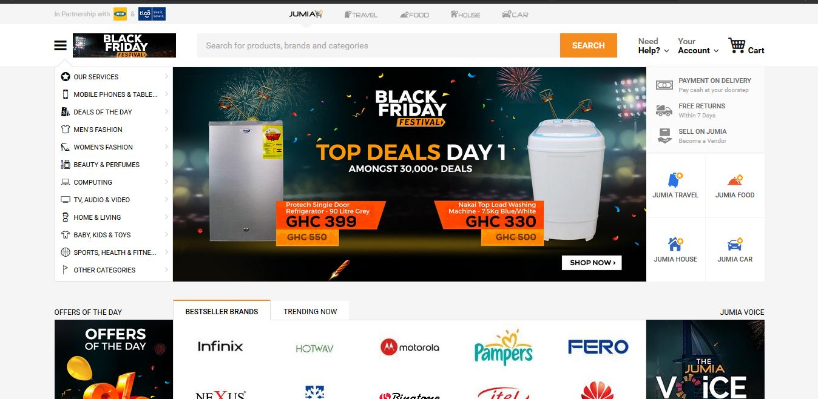

Jumia.com is an open business-to-consumer (B2C) platform enabling businesses to reach Africa's vast and growing consumer market. Jumia.com has established itself as the destination for quality, branded products, catering to an increasingly sophisticated African consumer(s). It is the most visited B2C online retail website in Africa.

 You can shop the widest selection of electronics, fashion, home appliances, kids’ items and more in Ghana and have them shipped directly to your home or office at your  
convenience! They offer free returns and various payment options including cash on delivery. With affordable prices and great products.

## 2.5.4 Ahonya

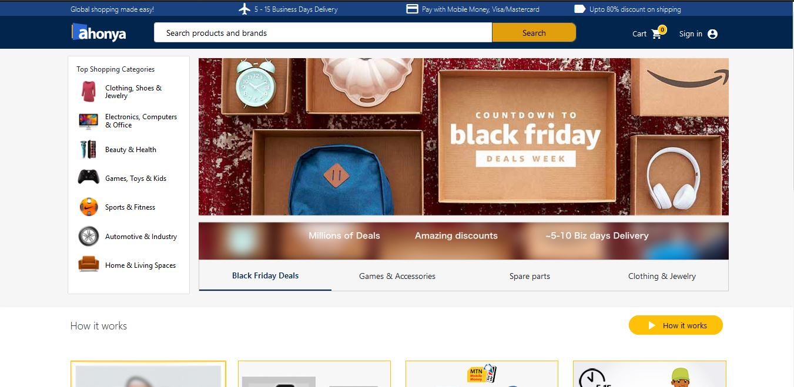

Ahonya.com allows you to shop for genuine electronics and fashion items on US & UK stores and have it delivered to your doorstep.

On www.ahonya.com we have painstakingly selected and listed over 10million products from US & UK stores. Just search and buy the products you love across multiple categories

Find products on any US & UK store, provide us with the link and we will buy and deliver it to you in 5-10 days.

## 2.5.5 Azaliabooks

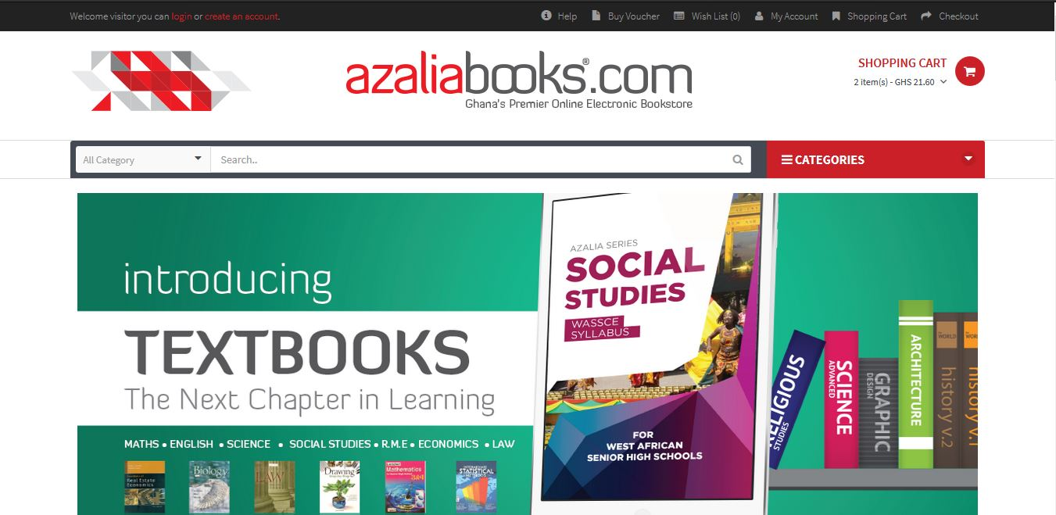

[Azaliabooks.com](http://Azaliabooks.com/) is a website owned and operated by AZALIA. Their sole purpose is to promote the works of writers, publishers, photographers and other professionals in the creative arts industry, in order to explore, inspire and enrich lives. On this website, you can shop for electronic books (e-books) of all genres including educational materials, Christian literature, fiction & non-fiction novels, magazines, newspapers, etc. It also serves as an excellent online market for selling the soft copy of books.

## 2.5.6 eShopAfrica

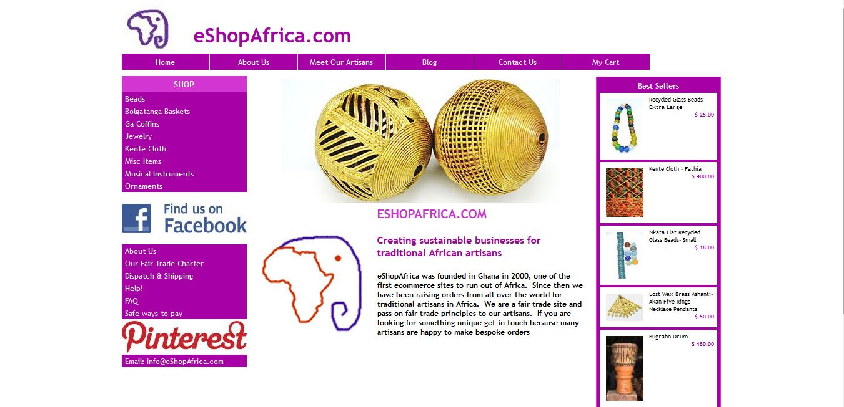

eShopAfrica.com is a fair trade social business creating sustainable businesses for traditional African artisans. Based in Accra, Ghana. eShopAfrica.com has been trading online since 2001 and was one of the first e-commerce sites based in Africa. The company is registered in Ghana as an export only company promoting products from the non-traditional sector. They invest in their artisans enabling them to find new markets and grow their businesses in a sustainable way. Where possible we support artisans from the least developed sectors of society including artisan groups and community organizations.

## 2.5.7 Zoobashop

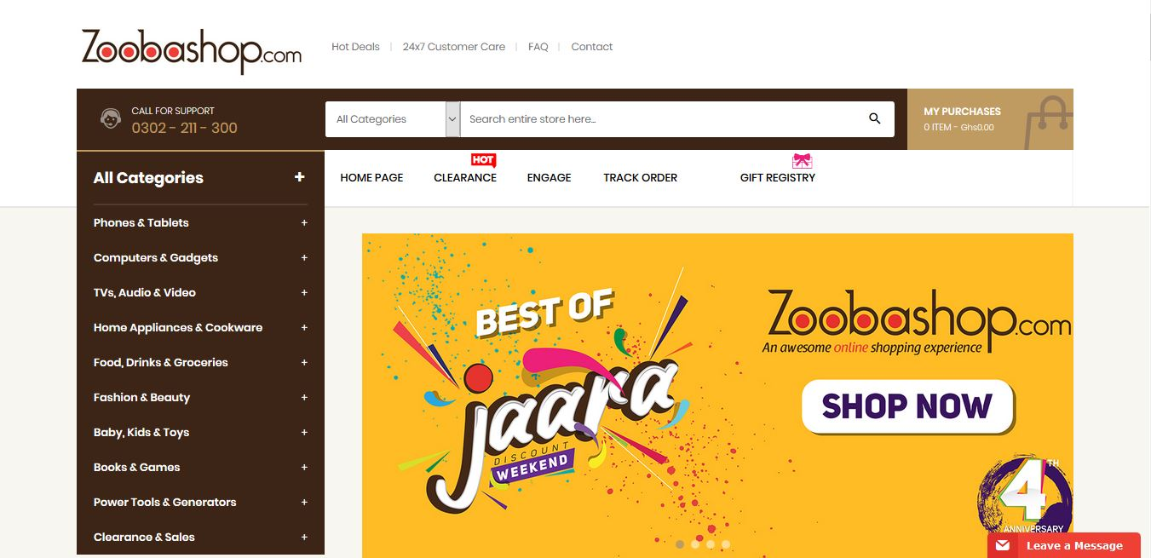

**Zoobashop.com** is a wholly Ghanaian owned online retail. They sell products from different categories  
like electronics, home appliances, fashion, accessories, books, foods, baby products and many more.  
You can shop with your debit & credit cards(Visa & MasterCard branded ATM cards), cash on  
delivery, mobile money among others. Here are some reviews we found about them.

## 2.5.8 Telefonika

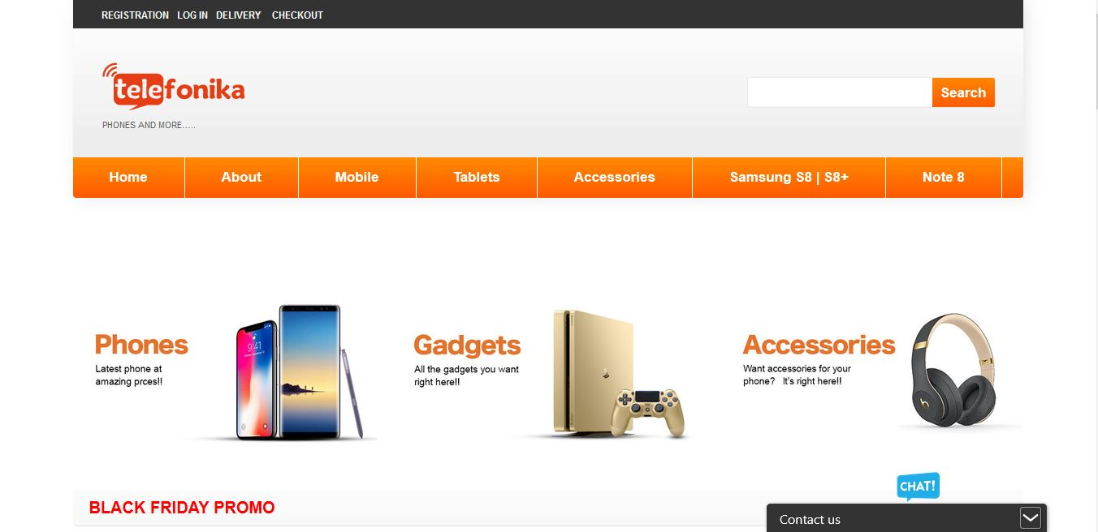

**Telefonika** is a telecommunication company, trading in mobile phones and accessories, telecommunication equipment, electronic products and gadgets which started in the year 2000 in Osu and has grown over the years and now has (10) branches in vantage parts of Accra.

At **Telefonika**, we take pride in paying attention to details and providing after-sale service for all our products and services. Our service center is well staffed with professional technicians from diverse parts of the world, who have been trained and are well versed in mobile telecommunication and IT systems to meet our client needs.

Our focus is beyond phones and accessories; we take value in meeting the needs of our customers. Because we are passionate about our work and our clients, and delivering quality service is our ultimate goal. that is why we have become a household name among individuals and institutions alike.

## 2.5.9 Cheki

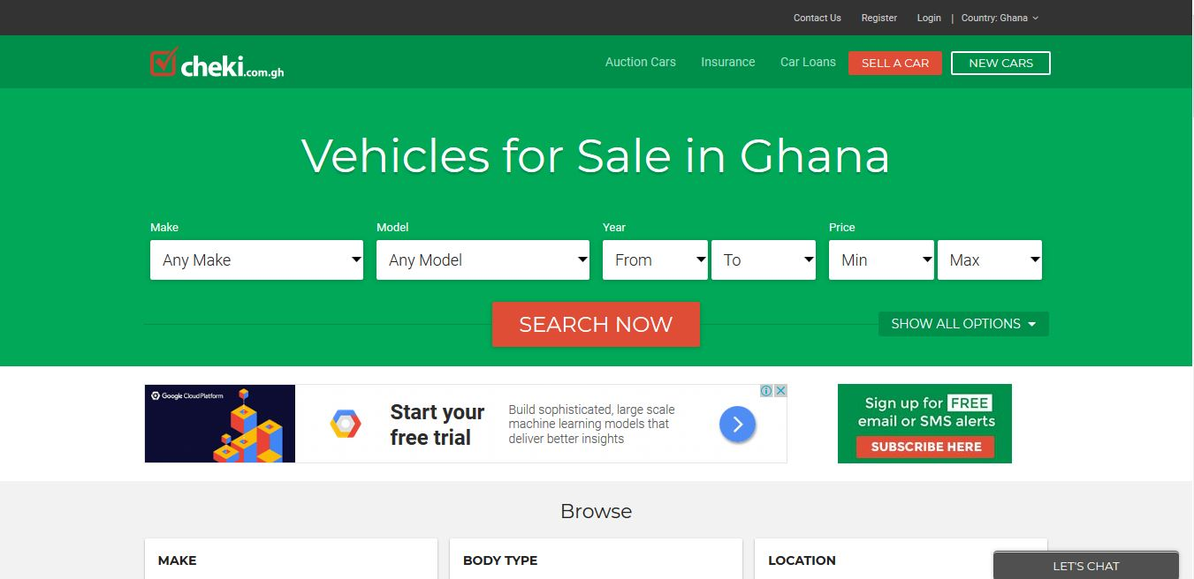

Established in 2010, cheki.com. is Ghana’s #1 Auto website with more car buyers and car sellers than any other site in Ghana.

Cheki.com.gh is an online marketplace where all of Ghana’s leading car dealers, importers and private sellers post their cars for sale in Ghana. They do not sell cars directly but rather offer a state of the art advertising medium for users to buy and sell their cars, 4WDs, vans, bikes and trucks and other vehicles.

They also offer a one stop destination for all buyers of Japanese import cars to Ghana, by centrally hosting all the cars of many leading Japanese car dealers and importers to Ghana.

## 2.5.10 Baahe

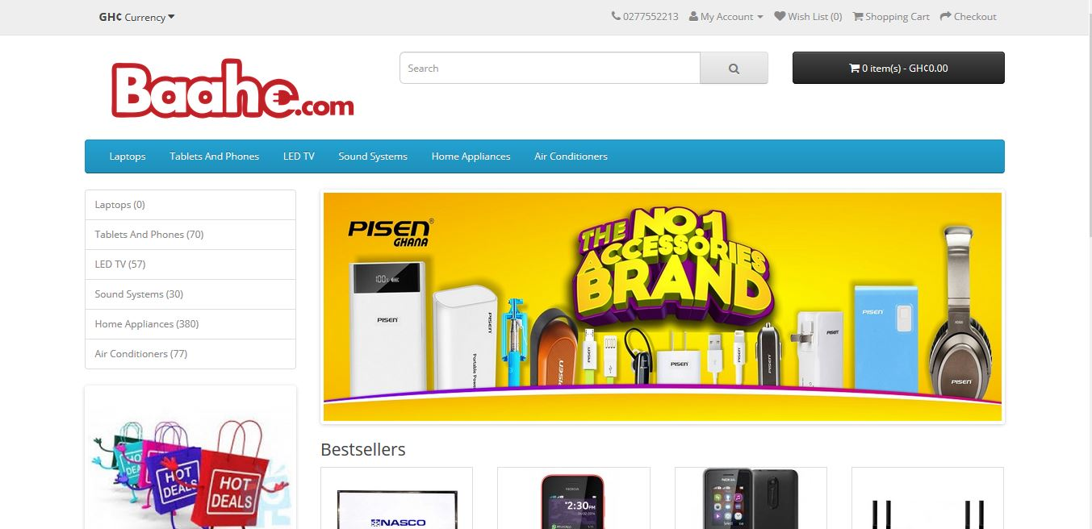

Baahe.com excels in bridging the gap between high quality consumer electronics goods and every consumer in Ghana and beyond. Their mission is to deliver quality consumer electronic goods and appliances right to your doorstep conveniently through our online retail shop. They believe in service to mankind in any possible way therefore our dedication to meeting everyone's electronic needs with prompt and amazing customer service.

## 2.6 Review of Existing Implementations (Designs and Features)

|  |  |  |
| --- | --- | --- |
| **Vendors** | **Design & Features** | **Gap / Limitations** |
| Amazon | * Bi - Lingual (English, Spanish) * Shopping Cart * Checkout * Product recommendations * Payment Gateway * User account * Detailed product description * Customer reviews of the product * Free or competitive shipping options * Advanced navigation and search functions * A fast guest check-out option * Security Features * High-Resolution Photos * Mobile-Friendly * Wish Lists * Special Offers * Live Chat Functionality and Contact Details * Social Media Integration | * No API for developers * Available in only two languages (English and Spanish) |
| Walmart | * Uni-Lingual (English) * Shopping Cart * Checkout * Product recommendations * Payment Gateway * User account * Detailed product description * Customer reviews of the product * Free or competitive shipping options * Advanced navigation and search functions * A fast guest check-out option * Security Features * High-Resolution Photos * Mobile-Friendly * Wish Lists * Special Offers * Live Chat Functionality and Contact Details * Social Media Integration | * No API for developers * Available in only English |
| Jumia Ghana | * Uni-Lingual (English) * Shopping Cart * Checkout * Payment Gateway * User account * Detailed product description * Customer reviews of the product * Free or competitive shipping options * Advanced navigation and search functions * A fast guest check-out option * Security Features * High-Resolution Photos * Mobile-Friendly * Wish Lists * Special Offers * Live Chat Functionality and Contact Details * Social Media Integration | * No API for developers * Available in only English * No product recommendations |
| Ahonya | * Uni-Lingual (English) * Shopping Cart * Checkout * Payment Gateway * User account * Detailed product description * Customer reviews of the product * Free or competitive shipping options * Advanced navigation and search functions * A fast guest check-out option * Security Features * High-Resolution Photos * Mobile-Friendly * Wish Lists * Special Offers * Live Chat Functionality and Contact Details * Social Media Integration | * No API for developers * Available in only English * No product recommendations |
| Azaliabooks | * Uni-Lingual (English) * Shopping Cart * Checkout * Payment Gateway * User account * Detailed product description * Customer reviews of the product * Free or competitive shipping options * Advanced navigation and search functions * A fast guest check-out option * Security Features * High-Resolution Photos * Mobile-Friendly * Wish Lists * Special Offers * Live Chat Functionality and Contact Details * Social Media Integration | * No API for developers * Available in only English * No product recommendations |
| eShopAfrica | * Uni-Lingual (English) * Shopping Cart * Checkout * Payment Gateway * User account * Detailed product description * Free or competitive shipping options * Advanced navigation and search functions * A fast guest check-out option * Security Features * High-Resolution Photos * Mobile-Friendly * Wish Lists * Special Offers * Live Chat Functionality and Contact Details * Social Media Integration | * No API for developers * Available in only English * No product recommendations |
| Zoobashop | * Uni-Lingual (English) * Shopping Cart * Checkout * Payment Gateway * User account * Detailed product description * Customer reviews of the product * Free or competitive shipping options * Advanced navigation and search functions * A fast guest check-out option * High-Resolution Photos * Mobile-Friendly * Wish Lists * Special Offers * Live Chat Functionality and Contact Details * Social Media Integration | * No API for developers * Available in only English * No product recommendations |
| Telefonika | * Uni-Lingual (English) * Shopping Cart * Checkout * Payment Gateway * User account * Detailed product description * Customer reviews of the product * Free or competitive shipping options * Advanced navigation and search functions * A fast guest check-out option * Security Features * High-Resolution Photos * Mobile-Friendly * Wish Lists * Special Offers * Live Chat Functionality and Contact Details * Social Media Integration | * No API for developers * Available in only English * No product recommendations |
| Cheki | * Uni-Lingual (English) * Shopping Cart * Checkout * Payment Gateway * User account * Detailed product description * Customer reviews of the product * Free or competitive shipping options * Advanced navigation and search functions * A fast guest check-out option * Security Features * High-Resolution Photos * Mobile-Friendly * Wish Lists * Special Offers * Live Chat Functionality and Contact Details * Social Media Integration | * No API for developers * Available in only English * No product recommendations |
| Baahe | * Uni-Lingual (English) * Shopping Cart * Checkout * Payment Gateway * User account * Detailed product description * Customer reviews of the product * Free or competitive shipping options * Advanced navigation and search functions * A fast guest check-out option * Security Features * High-Resolution Photos * Mobile-Friendly * Wish Lists * Special Offers * Live Chat Functionality and Contact Details * Social Media Integration | * No API for developers * Available in only English * No product recommendations |

Upon careful analysis of the above applications from different vendors, I came out with the following findings;

* I realized that almost all the e-commerce sites have these designs and features Shopping Cart, Checkout, Payment Gateway, User account, Detailed product description, Customer reviews of the product, Free or competitive shipping options, Advanced navigation and search functions, fast guest check-out option, Security Features, High-Resolution Photos, Mobile-Friendly, Wish Lists, Special Offers, Social Media Integration, Live Chat Functionality and Contact Details which makes online shopping easier.
* I also realized that almost all e-commerce websites are Uni-Lingual, that is, are available in only the English language and they do not provide an interface for other developers to use features of their platform such as product pictures, categories of product in their project.
* I also realized that most of these e-commerce websites in Ghana do not provide product recommendation for customers. This sophisticated additional feature offers good pairings or suggests similar products for users as a means of ‘upselling’ their products. Think about the consumer purchasing a phone who might be persuaded to get a cover or a set of earphones for that phone because **a)** they are already spending money and **b)** it’s a clever pairing. This technique results in extra revenue generation and also helps customers ‘filter’ their choices by perhaps going for something similar to what they’re already looking at.

## 2.7 Benefits and Challenges of Implementations

My main aim is to address some of the shortfalls of the existing systems and to provide a friendlier, robust and reliable service for the e-commerce industry. The system will ensure the following benefits and will also have some challenges:

## 2.7.1 Benefits

* Provide a general-purpose e-commerce store where customers can buy any product (such as books, CDs, computers, mobile phones, electronic items, and home appliances) from the comfort of home through the Internet. The advantage here is that the online shop owners has the flexibility to customize the system to suit the needs of its business.
* Provide a platform for the e-commerce businesses in Ghana to go global so that they can increase their patronage by consumers. This has an added advantage of increasing the revenues of the e-commerce business in Ghana that use my system.
* Provide platform for online shop owners to get their monies before successful order is placed. In this part of our world, if people do not pay before the order is placed, some might end up not showing up for their orders and the shop owners may incur debt. I hope to employ PayPal payment gateway platform to enable customers pay before their orders are placed successfully.
* Provide other developers an easy way around of integrating features of this project such pictures of products, products and categories of product into their own projects using APIs.

## 2.7.2 Challenges

Every implantation has challenges and this project is no exception and some of the challenges of this project are:

* Time to complete this project. This is as a result of the fact that I have to make time for classes and also for developing the project.
* Implementing the mobile money payment system. This is due to the fact that most of these mobile money merchants do not have APIs to make integration of mobile money into my system.

## 2.8 Trends in the Industry / Future Direction

As e-commerce technology continually evolves, customer experience is becoming increasingly essential to the conversion of sales. Some retailers are currently planning to create and sustain customer value by providing sophisticated digital experiences that deliver orders more quickly, blend physical and digital capabilities, and simplify ordering procedures.  Data-as-a service and ecommerce, Chatbots, Drones, droids, augmented reality goggles, Blockchain and bitcoin are some of the more prominent innovations on the horizon that are expected to transform the e-commerce industry.

## 2.8.1 Data-as-a-service and ecommerce

If 92% of Internet users regularly read product reviews and comments from other buyers, it’s because uncertainty is a huge obstacle to online purchasing. The more information there is available about a product (pictures, reviews, descriptions, specifications, etc.), the less reluctant people will be to buy it online. However, constantly refreshing the information on each individual product on a website is a near-impossible task for any merchant who doesn’t have esque resources.

In the future, many retailers will start working with data aggregators that compile data on millions of products: pictures, descriptions, price comparisons, specifications, UPC codes, reviews, and comments. There are even aggregators that contain data on millions of pieces of clothing that can be used to suggest the perfect size! A merchant will be able to link its site to these databases to automatically update product information. Say goodbye to uncertainty and to poor product descriptions!

## 2.8.2 Chatbots

Chatbots otherwise known as messenger bots is a piece of software that can be used by the retailer to chat with customers via text or voice.

In the future, many consumers will have their first interaction with a chatbot, a fully automated chat agent that will answer their questions and act as the first point of contact with the brand. A chatbot increases the number of platforms on which a brand can transact by offering guided, interactive browsing at all times.

Chatbots will soon become as commonplace as automated phone systems, only much more interactive and interesting. At the same time, store sales staff will become more important than ever, as they’ll be increasingly involved in the online experience.

For example, Fast food chain **Taco Bell** unveiled its TacoBot on the popular messaging platform Slack, which allows customers to order food by messaging TacoBot, which asks all the right questions. Also, **Burger King and Pizza Hut** customers can order food directly through Facebook Messenger and Twitter by messaging the restaurant chains’ bots.

## 2.8.3 Drone Delivery

The growing popularity and availability of drone delivery is expected to be one of the most innovative technologies in the retail industry over the next decade. Though regulations (primarily concerning airspace governance) have yet to be established in some parts of the world and are therefore delaying the widespread use of drones, the new delivery system has already played a big role in delivering products to aid disaster relief efforts. The existing delivery technology for these efforts easily translates to the online retail industry, with major retail and delivery companies exploring how they can incorporate drone technology and future e-commerce solutions.

Most drones have a cruising altitude of 400 feet and can fly at roughly 60 miles per hour. Radius distances vary from 10 to 15 miles away depending on the prototype, and drones can generally carry packages up to 5 pounds. In time, drones could enable some companies to offer same-day shipping, or even same-hour delivery in highly populous areas. These faster delivery times along with a growing number of online shoppers worldwide will likely encourage more online purchases in the future.

For example, Australia Post is currently testing drones to commercially deliver parcels to civilian addresses, and sites in the U.S. and Europe have been quick to build airports specifically for drones (internally referred to as “droneports”).

## 2.8.4 Droid Delivery

A more grounded solution, droid delivery is slowly gaining attention as well. Droids are little robots, typically built with six wagon wheels that travel along sidewalks at a pedestrian pace (usually about four miles per hour, though most are capable of speeds more than twice as fast). The most popular delivery droid so far has been created by Starship Technologies, a startup assembled by the founding engineers of Skype. This particular droid weighs between 20 and 30 pounds, is capable of transporting roughly 20 pounds of goods in 30 minutes or less, and is designed to complete the final mile of a delivery. They can climb small sets of stairs, are equipped with nine cameras to stream live video back to their base, a microphone for two-way communication with customers, GPS tracking (for both their base and shoppers), and censors that help it navigate any obstacles or foot traffic on sidewalks. Environmentalists like these little delivery droids because they use less energy than most lightbulbs and because they not only reduce vehicle emissions but are also generally quicker to deliver products. In fact, nearly 30% of transportation costs are incurred during the last mile, when delivery drivers must search for a parking space and leave their car idling while they make the last few steps of the trip walking to the customers’ front door. Delivery droids will make the whole process less expensive and will therefore appeal to retailers and fulfilment companies looking to cut cost and delivery times. Around the world, luxury hotels have implemented delivery droids to boost their hospitality capabilities. For example, hotel droids are able to bring necessities like extra towels, soaps, and even room service meals. In Australia, Domino’s Pizza introduced its own robot to deliver pizzas quickly to customers, avoiding traffic and parking problems.

## 2.8.5 Augmented Reality Technology

In terms of discovering products, retailers have implemented the use of augmented reality to increase online sales. In-home augmented or virtual reality technology comes in the form of headsets or goggles that create an interactive, 3-D shopping experience for the user. It provides retailers an in-home extension of their physical stores and can potentially increase sales with simplistic user experiences and built-in upselling features. Goggle technologies or virtual reality headsets (such as Microsoft HoloLens, Sony Smart Eyeglass, Oculus Rift) are growing in popularity due to their multi-use properties in terms of retail marketing. With goggles, shoppers can look into their mirror at home and transform it into an interactive dressing room. The goggles can then help the shopper choose correct clothing sizes with a virtual view of how the garments will fit as well as suggest matching accessories. By utilizing this technology to accurately choose garment sizes, the percentage of online return shipments may also decrease.

Home design will also be transformed with the use of goggle technologies. Leading furniture companies will be able to display what their products will look like within a shopper’s home and allow the shopper to interact with the furniture in order to choose what styles they like best. For example, a customer will be able to select and visualize a couch, moving it to different sides of the room to see how they like it or even try a different size to make sure it fits in a specific space.

## 2.8.6 Blockchain

Blockchain is essentially a shared ledgering technology that allow companies and their partners to accurately manage and track complex digital transactions, as well as securely store the digital values or objects involved in those transactions. Wal-Mart is one of the first retailers to plan [an international implementation of blockchain](https://www.retaildive.com/news/wal-mart-looks-to-blockchain-for-produce-pork-tracking/432603/) as it looks to impose better tracking of its pork and produce transactions in China.

More retailers, especially the largest international ones, may be ready to use blockchain for similar applications, though doing so requires an embrace of digital economy principles that may still be a stretch for some.

## 2.8.7 Bitcoin

Bitcoin is a digital currency which allows transactions to be performed without banks or any other middlemen. Transactions from consumer’s wallets are processed, verified and publicly recorded by so-called bitcoin enthusiasts. And, there aren’t any transaction fees.

Bitcoin is a new cryptocurrency, which created by an unknown programmer (or a group of programmers) under the pseudonym Satoci Nakamoto. This happened in 2009. Nobody knows where this man is and what his name is in the real world. Cryptocurrency Bitcoin has the basic functions and properties of conventional money from different countries. It could exchange, stored and used to purchase. However, Bitcoin is cryptocurrency, which is a type of digital currency. Its emissions and accounting based on different cryptographic methods. A decentralized operation occurs, in a distributed computer network. Cryptocurrency - this is the real software, the growth rate of which depends on supply and demand, not by subsequent investors. Each member of the network can make instant transactions cryptocurrency without intermediaries. That is, the buyer sends the money directly to the seller. No need to go to the bank, you simply send Bitcoins to the person. Coins in the system are the cryptographic (mathematical) hash functions. Each of them is completely unique and cannot be used twice. Bitcoin can be used to purchase goods and services on the Internet anonymously. Moreover, it is easier and cheaper to make international payments because Bitcoin is not tied to a particular country. To store Bitcoins, have a few options. Offline purse is being installed and is created on your PC. Usually, it is encrypted to prevent tampering. But, there are some cons, if you forget the password to log into a purse or on your computer hard drive died you lost your money. Online Bitcoin wallet has advantages over the offline version. You can access it using not only PCs but also tablet or phone. One of the main problems of these wallets is that all the data stored on the server. Many online stores or retail outlets that accept bitcoin currency side by side with local currency, debit cards or credit cards, opens the window of opportunity for users to compare the benefits of shopping via bitcoin payment.

## 2.9 Summary

In this chapter, I started with the overview of the subject area which is Ecommerce and online shopping. I proceeded with current research issues in Ecommerce business. I then took a look at the technologies available both past and present and later reviewed and highlighted similar implementations from ten vendors namely **Amazon.com,Walmart.com,Jumia.com, Ahonya.com,Azaliabooks.com,eShopAfrica.com,Zoobashop.com,Telefonika.com,Cheki.com and Baahe.com**. I went further to look at the benefits and challenges of my implementation and finally concluded with the trends and Future Direction in the ecommerce business.